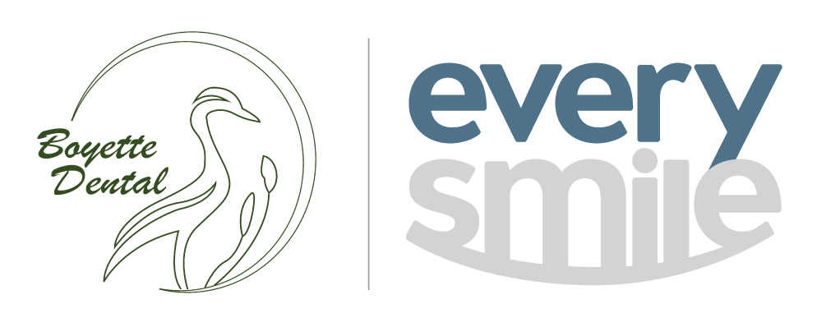

**EverySmile Dental**

10825 Boyette Road Riverview, FL 33569 │ (813) 741-0483

**Social Media Informed Consent**

**EverySmile Dental** is pleased to participate in social media outlets such as Facebook, our website page, etc. Through these venues, we share staff pictures, office updates, new contests and other fun and helpful information updates that may benefit our patients. With the expressed permission of our patients, we are pleased to share posts congratulating patients on completing their treatment, announcing contest winners, and posting fun selfies and photos with our patients.

* I hereby grant **EverySmile Dental** permission to take photographs of me, and to publish those photographs for any lawful purpose including, but not limited to, case presentations, promotional purposes and on their website and/or social media accounts.
* I do not consent to my photographs being published, posted, or shared on social media.

__________________________________________

**Name of Patient**

__________________________________________ ________________________

**Signature of Patient (or Responsible Party) Date**